Vegan Spinach Balls - Make Ahead Appetizer
Vegan Spinach Balls that make a great hot appetizer or a healthy snack. Make ahead and keep in the freezer. Pop in the oven when ready to eat.
Servings 20 Balls

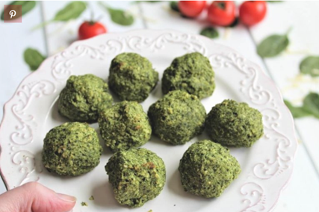
Ingredients

1x 16oz bag frozen spinach

⅓cup vegan margarine

1½cup breadcrumbs

¼ cup grated vegan cheese

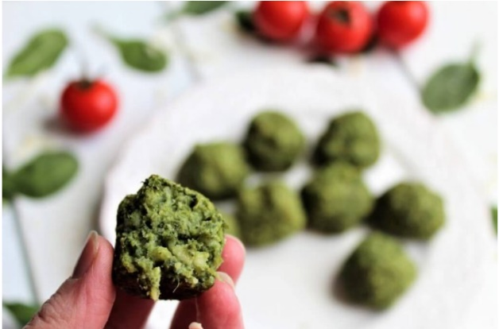
¼cup nutritional yeast

½ cup silken tofu

½ tsp salt (more or less to taste)

1 dash ground pepper (to taste)

Method
1.Thaw frozen spinach and press the spinach to the side of a bowl with a spatula to squeeze out all excess water and drain.
2.Add all ingredients in a food processor and then pulse a few times until all ingredients are mixed thoroughly.
3.Take spoonfuls of the mixture and roll it into 1 inch balls with your hands.
4.Place the balls on a baking tray about an inch apart and set in the freezer for about an hour until they are frozen.
5.Remove frozen balls from the baking tray and place into airtight freezer bags or containers. Put back in freezer until ready to use. Can be kept frozen for about 3 months.
When ready to eat …Preheat oven to 190⁰C or 170⁰C fan oven.
1.Place frozen balls on a baking tray about 1 inch apart.
2. Bake from frozen for 20 minutes until the balls are firm and the outside is just barely starting to brown.
3. Serve hot
Notes
A tofu press, if you have one, works well to drain the spinach. The spinach does need to be drained well.
Spinach balls go well with Pea, Feta & Mint Dip recipe.
Applewood Vegan cheese is a good cheese option.
Cooking times will vary slightly on your oven and on the size of the balls.
Breadcrumbs are useful and easy to make at home and store in an airtight container.

Adapted from recipe https://thehiddenveggies.com/vegan-spinach-balls/

