SEAG: VILLAGE POND TIDY-UP
Elsie Rogers (8) in association with SEAG

Studridge Pond is important for our village as it can support a large range of British wildlife, but unfortunately it had become overgrown and ducks or frogs are no longer living there. With help from lots of volunteers, we planned to carry out a big tidy up before Christmas, but had to delay this when the water levels rose too high due to a water leak and lots of rain. With another lockdown in January we had to change our plans with a smaller, socially-distanced clear up before the weather got too cold, and I hope you will agree it looks much better now. We have even seen a pair of ducks visiting and really hope that they will stay. We are very grateful to Peter Symonds who led the clear up, and has also built a duck platform with the help of Duncan Wilson (thank you!). Peter explained that it was important to do this work during winter so we didn’t interrupt the breeding cycles of frogs, ducks and insects that we hope will return this year. Please stop by and take a look next time you are passing and for those of you wishing to have a closer look, Daisy Regan and I have created a pond “spotters sheet” which is free to collect from the village shop. SEAG would love to hear of any interesting sightings!

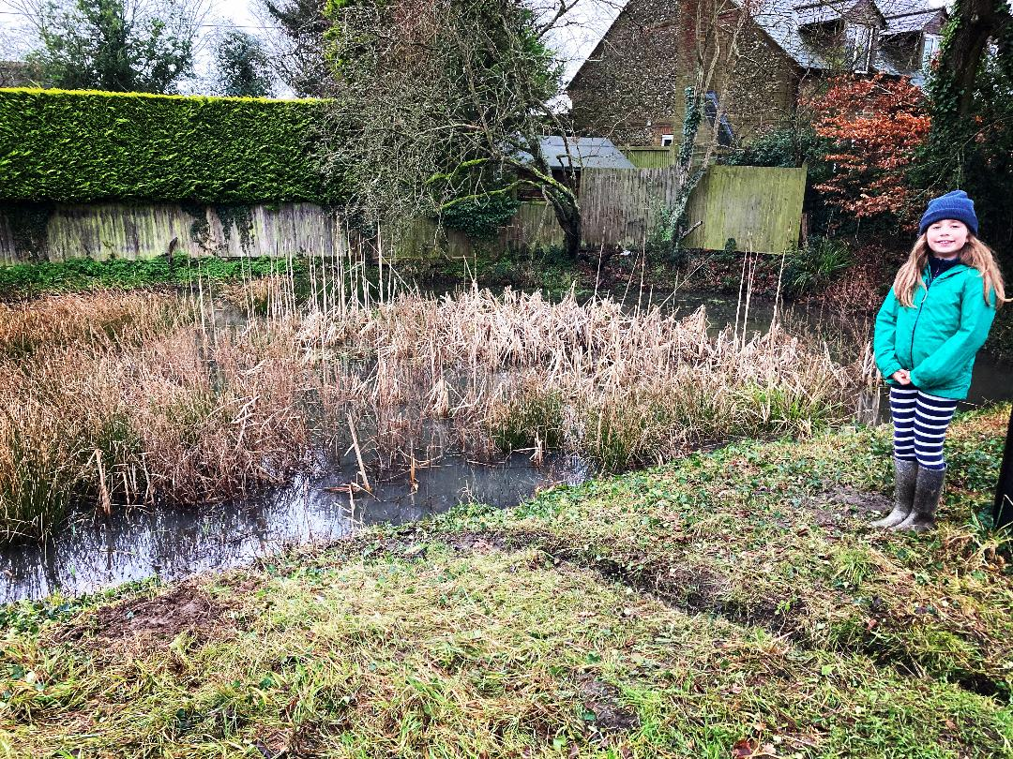

Note: Studridge Pond is the responsibility of the local parish council. SEAG approached them to request permission for this tidy up, and this was authorised by the council. We hope everyone will enjoy seeing more productive ecosystems in and around the pond this year, and that the tidy up will become an annual event to maintain rich biodiversity.

