Mushroom Paté en Croute
Wonderful for a special meal. Serves 8
This recipe can also be adapted to make ‘ Sausage’ rolls.

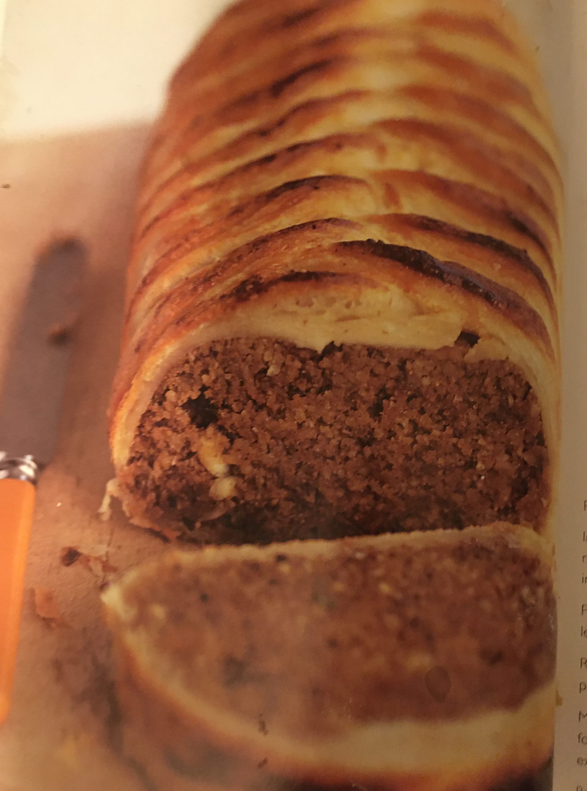

Ingredients:
2 large onions, chopped
2 tablespoons olive oil
2 garlic cloves, chopped
250g (9oz) chestnut mushrooms, sliced roughly
225g (8oz) cashews, powdered in a food processor
225g (8oz) ground almonds
225g (8oz) wholemeal breadcrumbs
2 tablespoons soy sauce
2 tablespoons lemon juice
2 teaspoons dried tarragon
1 teaspoon yeast extract
500g (1lb 2oz) puff pastry
Soya milk for brushing

Method:
- Preheat the oven to 200⁰C/400⁰F/Gas Mark 6.
- In a large saucepan, fry the onions in the olive oil for 7 minutes, until tender, then add the garlic and mushrooms and cook for a further 5 minutes, or until the mushrooms are tender. Then tip the mixture into a food processor and blend to a purée.
- Put the ground cashew nuts and almonds into a bowl with the breadcrumbs, the mushroom purée, soy sauce, lemon juice, tarragon and yeast extract and mix well. It will be quite stiff. Season with salt and pepper.
- Roll the puff pastry out on a lightly floured board to make a square about 38cm (15 in) in size. Transfer the pastry to a baking sheet and heap the mushroom mixture in the centre, forming it in to a loaf shape.
- Make diagonal cuts in the pastry about 1 cm (½ in)apart on each side of the mushroom mixture, then fold these up over the mushroom paté to make a kind of plait effect. Tuck in the ends neatly, trim off any extra bits and brush with soya milk.
- Bake for 40 minutes, or until the pastry is puffed and golden brown.
Adapted from: Low- GI Vegetarian Cookbook by Rose Elliott ISBN 978-0-563-53921-6
Onion gravy



 !" # $  %

&'
()
*+
,-. !' /$'
!-0' '/1!
).+/% 2. .-
/
342/

Onion gravy



 !" # $  %

&'
()
*+
,-. !' /$'
!-0' '/1!
).+/% 2. .-
/
342
Onion gravy



 !" # $  %

&'
()
*+
,-. !' /$'
!-0' '/1!
).+/% 2. .-
/
342
Onion gravy
Ingredients:
Oil 3 tbsp (45ml)
2 medium onions, sliced
100% wholemeal flour 2 tbsp (30ml)
Vegetable stock ¾pt (450ml) eg Marigold Swiss Vegetable Vegan Bouillon powder
Red wine (optional) 2 tbsp (30ml)
Tomato purée 2 tsp (10ml)
Yeast extract 1 tsp (5ml)

Method:
- Heat the oil in a frying pan, add the onion and cook until golden brown. Stir in the flour and cook for 1-2 minutes, stirring all the time. Add the stock, wine, tomato purée, yeast extract. Bring to the boil, then simmer very gently for 5 minutes.
- Liquidise and serve hot.

