Courgette and lemon risotto
A light and easy to make summer risotto; healthy and all plant-based.
The key, as always, is to not stop stirring.

Serves 3, Serve with garlic bread (vegan) and/or fresh spinach salad.

Ingredients:
2 large courgettes
225g (8oz) risotto rice
750ml (1¼ pts) vegetable stock (approx, will depend on consistency)
150ml (5fl oz) dry white wine
75g (2 and half oz) vegan butter (easily available in supermarkets)
1 onion finely chopped
1 garlic clove, finely chopped or grated
Zest of 1 lemon
Juice of half a lemon.
2 tbsp grated vegan parmesan cheese
Chopped parsley, as desired

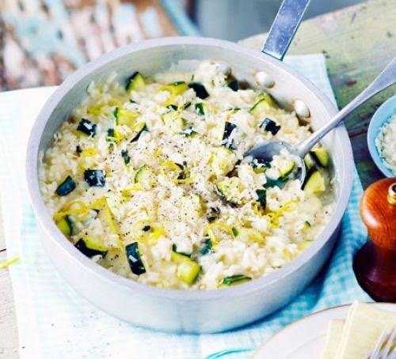

Method:
- Make up the stock as per packet instructions.
- Grate one courgette and slice and blanch the other in hot water for 2 minutes. Set aside for later.
- Melt half the butter in a large heavy based saucepan or frying pan over a low heat and cook the onion for 5 minutes, until softened. Add the garlic and rice, stirring continuously for 1 minute to coat the rice in the butter. Pour on the wine and continue to cook, stirring until all the liquid has been absorbed.
- Stir in one ladleful of stock – the rice should be at a slow simmer. Stir continuously until all the stock has been absorbed and the rice parts when a wooden spoon is run through it. Add another ladleful of stock and continue cooking in this way, adding stock one ladle at a time and stirring as you go.
- When the rice is almost ready and most of the stock has been used, add the courgettes into the pan. Cook, still stirring, for one more minute.
- Remove the pan from the heat and stir in the lemon zest and juice (as seems right), grated parmesan and remaining butter. Stir vigorously until the butter is melted, then cover with a lid and leave to stand for 1 minute.
- Add parsley to risotto. Serve with garlic bread and/or spinach salad.

Recipe and photo credit: Good food.com

