Chocolate peanut butter banana bites
Quick and easy. Store in freezer or fridge.

- Peel bananas, cut in half, then lengthways.
- Spread on layer of peanut butter
- Add crushed peanuts
- Dip in/pour on melted dark/vegan chocolate (Cadbury's Bournville works well)
- Cool on wire rack :)
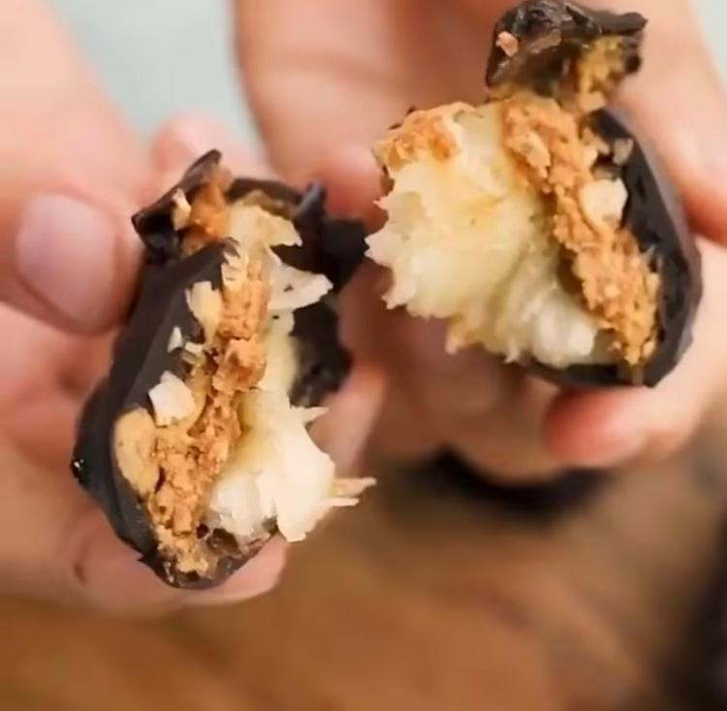

Photo credit: @fivesechealth

