Spicy Sweet Potato Moussaka

Serves 6. One-dish meals are so handy.

Ingredients:
1 medium aubergine
2 medium courgettes
400g (14oz) peeled and diced sweet potato
2 garlic cloves, crushed
Quarter/half tsp cayenne pepper (or omit)
Half tsp ground chipotle powder (or omit)
Freshly squeezed juice of 1 lime
180g (6 and half oz) macadamia nuts*, soaked for at least 2 hours.
85g (3 oz) sun-dried tomatoes in oil, drained
1 tsp ground cumin
1 tbsp freshly squeezed lemon juice (or apple cider vinegar)
1 tsp salt

* you can use cashew nuts instead and boil for 10 minutes to soften
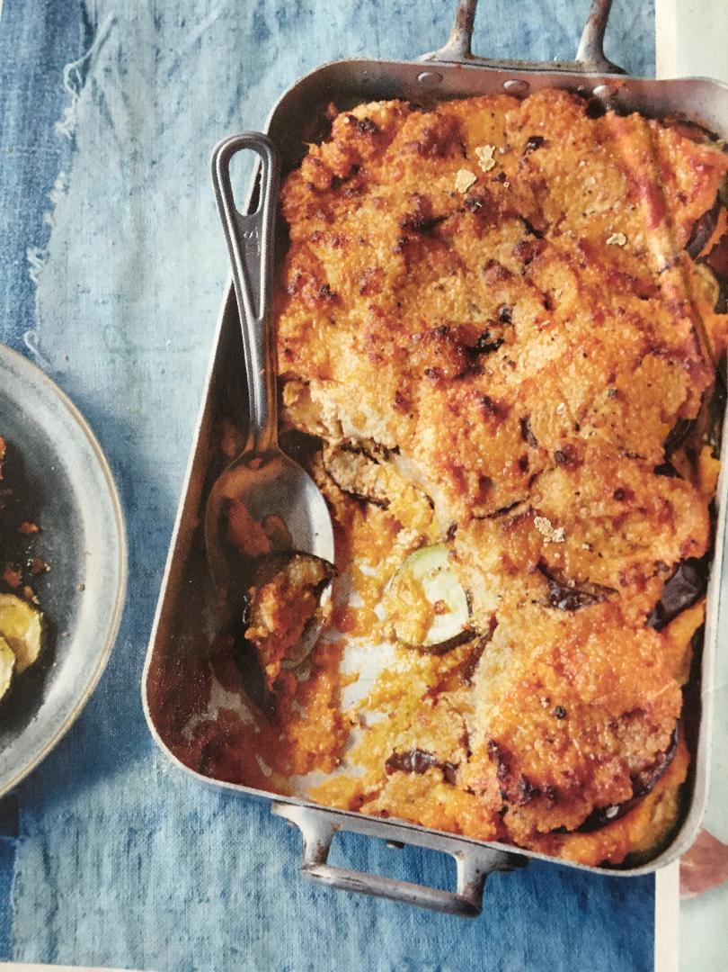

Instructions:

Preheat the oven to 180 degrees C/Gas Mark 4

- Slice the aubergine and courgette into rounds about 1cm (3/8 in) thick. Arrange on two greased baking sheets and then bake in the preheated oven for 15 minutes. Remove from the oven and set aside to cool, but keep the oven on.

- Meanwhile, boil the sweet potato cubes in a large pot of water over a medium-high heat for about 16 minutes, until soft. Drain and mash the sweet potato and mix in the crushed garlic, cayenne, chipotle and lime juice.

- Put the nuts, sun-dried tomatoes, cumin, lemon juice and salt in a blender and pulse until smooth.

- Once you have prepared all of the components, it's time to assemble the casserole. Place about 3 tbsp of the sweet potato mixture at the bottom of a 25x30 cm (10x12 in) casserole dish and spread thinly. It doesn't matter if it doesn't cover the entire surface.

- Layer some of the baked aubergine first, then spread a generous layer of the sweet potato mixture on top. Cover this with a layer of courgette, then some of the nut spread. Repeat until you have used up all of the ingredients, finishing with a thick layer of the nut mixture.

- Cover the moussaka with foil and bake in the still-warm oven for 20 minutes, then remove the foil and bake for another 15 minutes.

Adapted from Vegan Food and Living magazine. Issue 31
Photo from Vegan Food and Living magazine. Issue 31

