DON’T MOW LET IT GROW!
How you can play a vital role increasing our local plant biodiversity
by considering when to cut your verges.

Did you know that 97% of Britain’s wildflower habitat has been lot since WW2? This habitat not only enriches our native flora biodiversity, but also provides essential food and habitat to a wide range of invertebrates and other wildlife. Roadside areas are a vital habitat for wildflowers, with some 700 species growing on our verges – that’s 45% of the UK’s total flora. Wildflowers along our highways and byways can be an uplifting sight, contributing significantly to our well-being. However 87 of these species (including Deptford pink, tower mustard and spiked rampion) are currently threatened with extinction, due in large part to use of herbicides and roadside management policy of early mowing in Spring. But delaying the first cut til later in the Summer allows later-flowering wildflowers (such as white campion, betony, greater Knapweed and harebell) a chance to flower and drop seeds: a crucial opportunity to ensure future generations and continued biodiversity. And so we have a simple request to ask: please think hard before deploying herbicides and delay cutting your verges until mid July – end September to give our rich and beautiful flora and fauna a better future.

A number of our public roadside areas are managed and maintained by the local Parish Council, who have advised us that any roadside areas should not restrict traffic visibility in any way, and should not compromise safe passage for walkers on foot, so we would ask that any areas of transit should include a clear and safe pathway for public use. The 2000 Countryside & Rights of Way Act requires all government departments to show regard for conserving biodiversity (this includes verges) and in 2015 Highways England laid out new plans to include biodiversity as part of their overall strategy. In 2018 Plantlife (the organisation speaking up for UK wildflowers, plants and fungi www.plantlife.org) launched a campaign to get road verges managed better for nature. Since then over 300 local authorities have now declared a climate emergency, with reduced cutting regimes as recommended in Plantlife’s management guidelines, which is also helping councils to bring down carbon emissions and save money. Local councils across the county are saying no to mowing, and indicating that fewer cuts to verges is helping to save tens of thousands of pounds. Meanwhile a 2017 survey by YouGov for Friends of the Earth and Buglife made it clear that 81% of the public back the move to reduce cutting and move to a wildlife-friendly management approach.

Like me, you may have been using this time during Lockdown to make the most of our wonderful countryside, and been enjoying the arrival of lots of beautiful Spring flowers. I have spotted an abundance of violets, celandine, cowslips and garlic mustard, occasional honesty, cuckooflower and herb-robert. These early Spring-flowering species set their seed quickly and therefore are able to spread before the first cut of the mowers. Right now there is an explosion of bluebells with their heady scent in the woods. This flower also does well on some verges, but its seeds take longer to ripen and they rarely have a chance to spread before the mowers arrive.

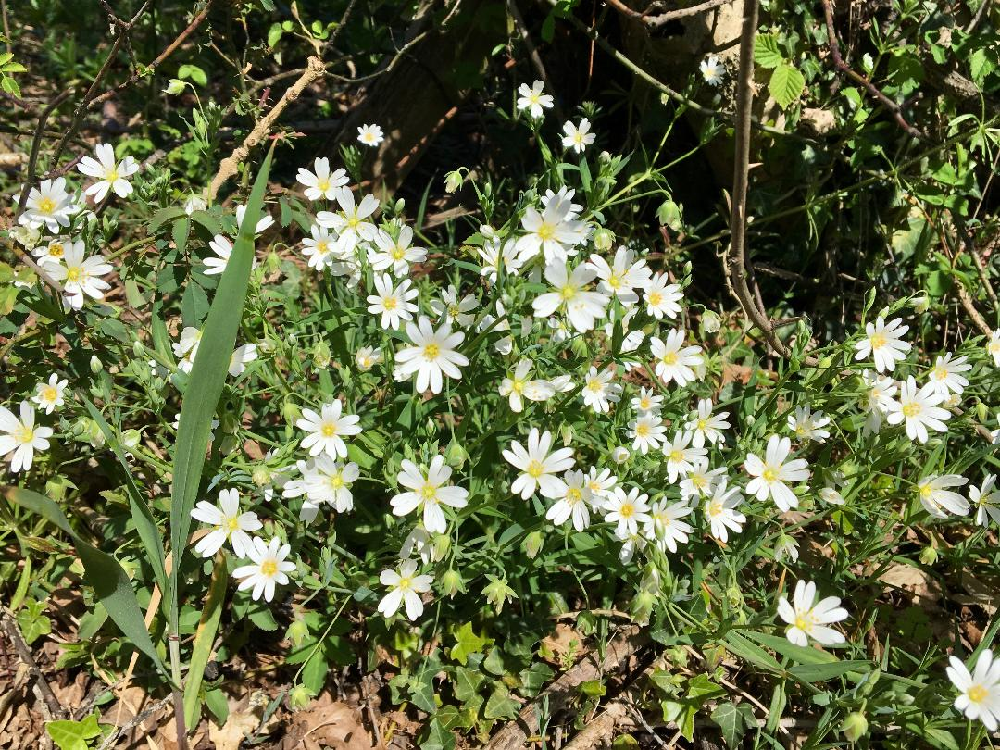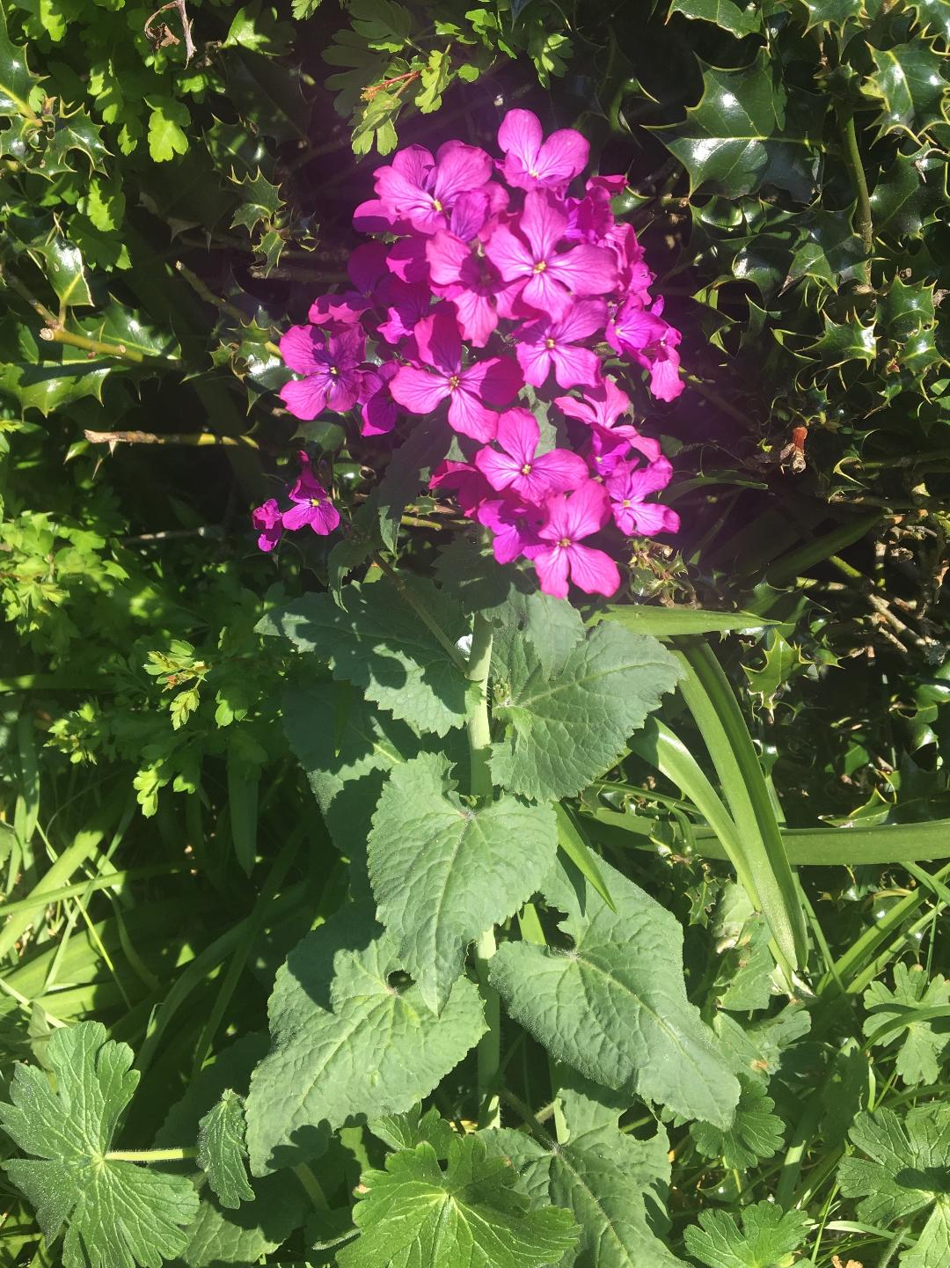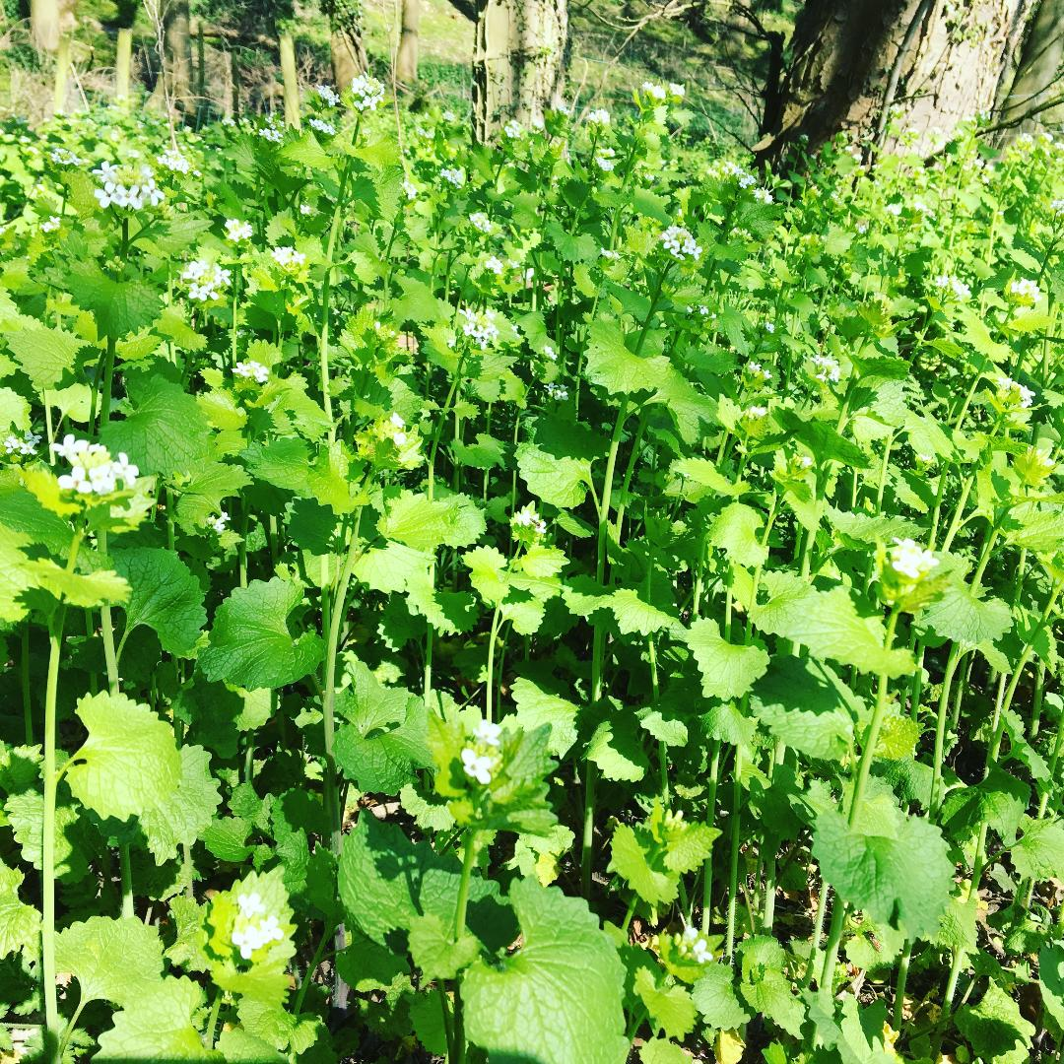
Stitchwort Honesty Garlic mustard (Jack-by-the-hedge)

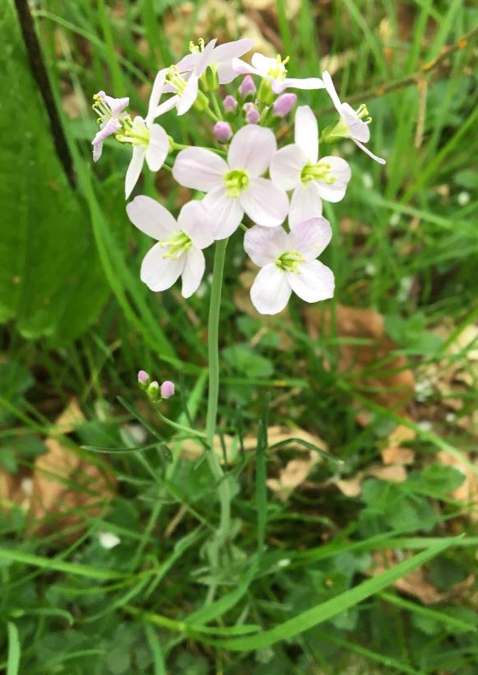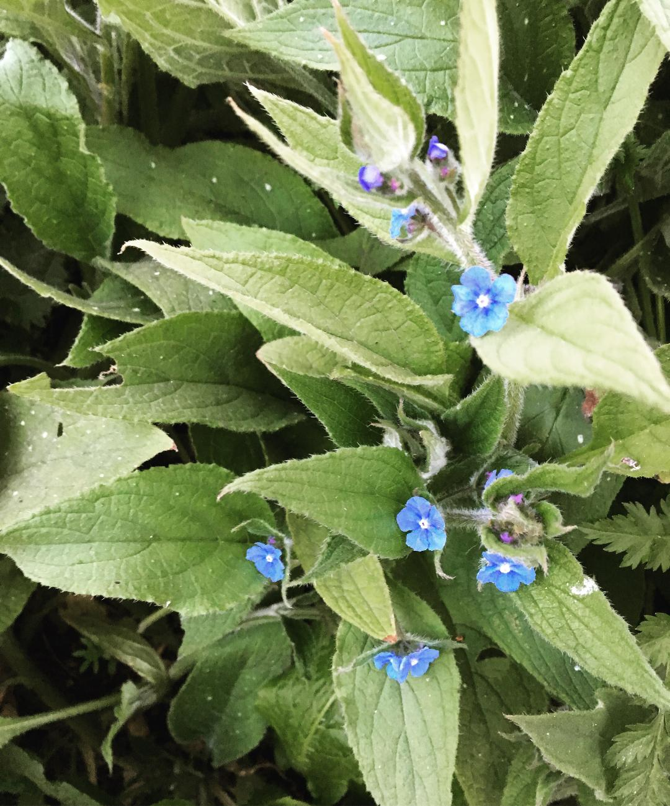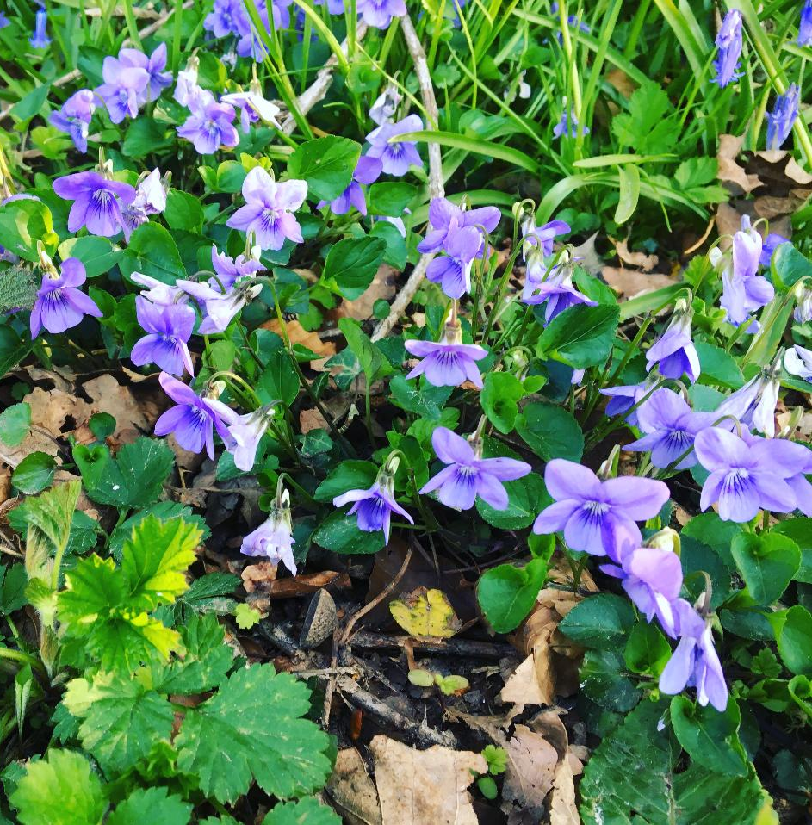
Cuckooflower Evergreen alkanet Dog violets

But species not faring so well include yellow rattle, eyebrights, once-common white campion, orchids, betony and field scabious. These are classic Summer-flowering annuals which need to set seed every year in order to survive. Early Spring cutting has all but eradicated them from verges, which is ironic as species such as yellow rattle actually help control the growth of grass by opening up the ground for other flora. As well as a reduction in the proliferation of roadside wildflowers during the Summer months, the decline of these Summer-flowering species has consequences for pollinating insects – which inevitably are also in decline without an abundance of food plant and habitat resources.

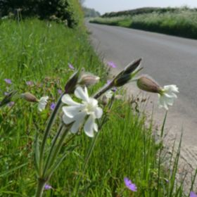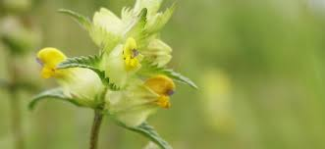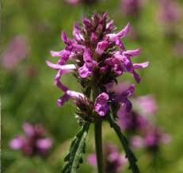

White campion (L) and Yellow rattle (M) Betony (R) (images courtesy of Plantlife.org)

We urge you to consider joining us in delaying your first mow of the year to ensure the survival and natural spread of both common and rare species - for their own sake, for the sake of the wildlife they support and the environmental benefits they bring, and to enhance the contact with nature experienced and enjoyed by all of us in Speen and North Dean.
A WILDLIFE-FRIENDLY VERGE APPROACH RECOMMENDED BY PLANTLIFE:

If only one cut is possible:
Cut between mid-July and the end of September. This allows plants to
flower and, importantly, gives time for seed to be set.

If more cuts are required, do one of the following:
Cut between mid-July and the end of September; then cut once more before Christmas.
This is the ideal option to conserve and enhance wildflowers, as it mimics the pattern of traditional meadow management.
Or...
Cut as early as possible, during February and March. This is before most verge plants flower and it won’t disturb ground-nesting birds. Cut the full verge again during September and October. This slightly later date for the second cut allows plants that were cut earlier in the year sufficient time to flower and set seed.

*** Please remember to ensure road traffic safety at all times ***

TIPS FOR PLANTING A WILDFLOWER MEADOW:

- Mow grass as short as possible and remove all cuttings to reduce nutrients (wildflowers like poor soil).
- Scarify (using a scarifier-SEAG may be able to help with contacts on this) or a low-tech version is to scratch up ground using a rake. Soil needs to be loose.
- Scatter wildflower seeds. If you can collect these from friends and neighbours nearby you are likely to have native seeds which will grow successfully in this area.
- Lightly tread in seeds and water during dry spells.
- If grass starts to return before any flower seedlings come up then mow again removing cuttings once again.
- Cut as per above article or consult expert in depth advice on Plantlife website.
- Quick and free ways of adding interest to wildflower areas include transporting any forget-me-nots and bulbs eg snowdrops, daffodils and bluebells from other areas in yours or friend’s gardens if they have excess. These will then either self-seed or multiply in situ.

For more information on wildflowers and plants and their roadside verge campaign please visit www.plantlife.org.uk and follow @seag.speen on Instagram as we spot and gather local wildlife imagery

Please sign the Plantlife petition asking our local council to reconsider its approach to roadside verge management: https://plantlife.love-wildflowers.org.uk/roadvergecampaign

Meanwhile if you are interested in encouraging biodiversity your own verge, or creating a wildflower meadow then further advice or the loan of a scarifier, please contact SEAG.

