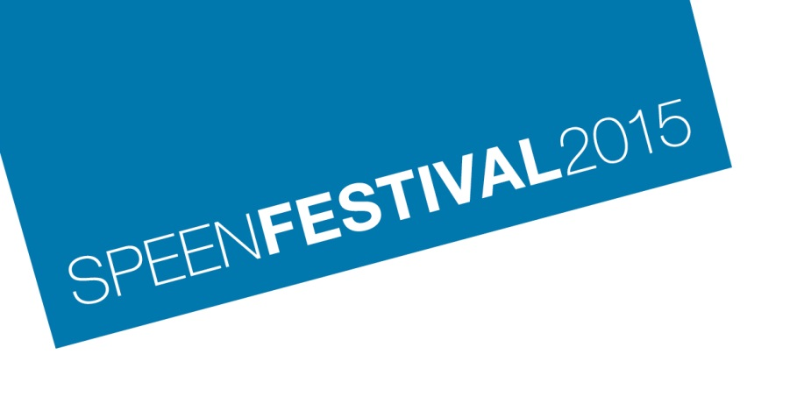
SCIENCE EVENING
Thursday 17th September
Speen Playing Field Marquee

Young Scientists Matter
5:30 to 6:30 pm Free admission

We invite our young people (ages 12 plus) to join us for an informal chat about science and scientists. What do scientists do? What are the important issues facing your future and how can science help? Maybe you have some good ideas of your own – we’d like to hear from you.
You are very welcome to join us later for Science Matters.

Science Matters
8:00 to 10:00 pm (doors open 7:30) Admission £5 (under16s £2)

Join us for our biennial panel discussion about science issues.

This year, we will begin with a light-hearted presentation about scientists called “Geeks, Freaks and Eggheads: the Image of Scientists” by Quentin Cooper. Quentin is a journalist with a strong background in science issues – he was the presenter of BBC Radio’s “Material World”.

Joining us on the panel, which will be chaired by Quentin, will be:

Subathra Subramaniam – Suba is a science teacher and also a choreographer exploring ways in
which science can interface with dance.

Dr John Emsley – John is a science writer who has published many books popularising science and has joined us at Science Matters twice before.

Barry Stickings – Barry is a Special Professor of Chemical Industry at the University of Nottingham and is active in a number of science-based university spin-outs.

As usual, we are expecting a lively debate with questions and opinions from the audience but questions ahead of time can be sent to barry@willottsfarm.net

Tickets available on line (www.speenfestival.org) or at the Box Office.

Wine, beer and soft drinks at the bar. Draft beer from our sponsor XT Brewery.

